Bahria University,

Karachi Campus

LAB EXPERIMENT NO.

**4**

LIST OF TASKS

|  |  |
| --- | --- |
| **TASK NO** | **OBJECTIVE** |
| 1 | Write a shell script to count all files and folders present in directory and stored the output into a text file and display its content on the terminal. |
| 2 | Write a single shell script that creates four different files, while taking the names of all created files as input from the user. As the files content, insert your name in the first file, registration number in the second and section details in the third. These should be followed by merging the contents of all three files into the fourth one. |
| 3 | Write a shell script that either performs a file sort, file search or directory listing operation based on the user’s selection of the operation he/she would like to execute. |
| 4 | Write a C program that takes values of two matrices of size (𝑚×1) and (1×𝑛) as input from the user. Multiply the above two matrixes and store the resulting (𝑚×𝑛) matrix in a 2D array. Display the contents of the first and second matrices and also the resulting matrix. Achieve alignment in the displayed content as much possible. |

Submitted On:

____________

(Date: DD/MM/YY)

**Task 1: Write a shell script to count all files and folders present in directory and stored the output into a text file and display its content on the terminal.**

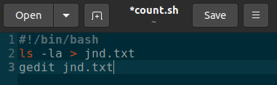**Solution:**

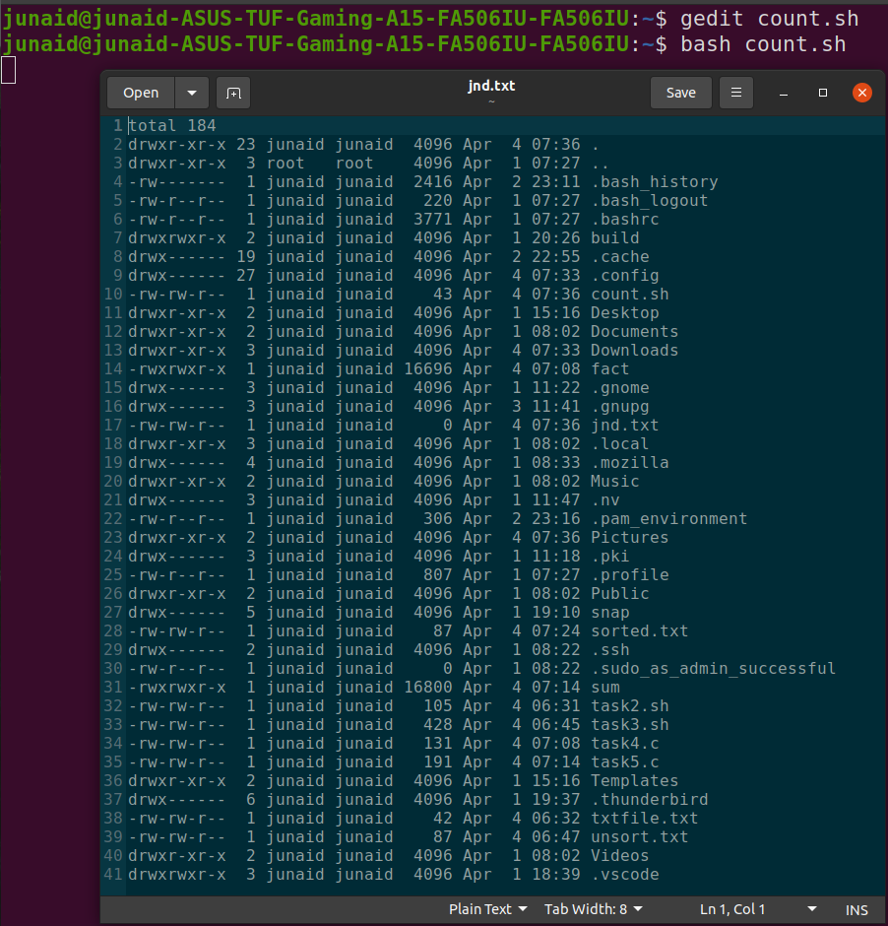**Output:**

**Task 2: Write a single shell script that creates four different files, while taking the names of all created files as input from the user. As the files content, insert your name in the first file, registration number in the second and section details in the third. These should be followed by merging the contents of all three files into the fourth one.**

**Solution:**

#!/bin/bash

echo "Enter name of 1st file : "

read file1

touch $file1

echo "Enter name of 2nd file : "

read file2

touch $file2

echo "Enter name of 3rd file : "

read file3

touch $file3

echo "Enter name of 4th file : "

read file4

touch $file4

echo "Enter your name : "

read content1

echo $content1 > $file1

cat $file1 >> $file4

echo "Enter your Reg no. : "

read content2

echo $content2 > $file2

cat $file2 >> $file4

echo "Enter your Section : "

read content3

echo $content3 > $file3

cat $file3 >> $file4

echo "-----Content of File 4-----"

cat $file4

**Output:**

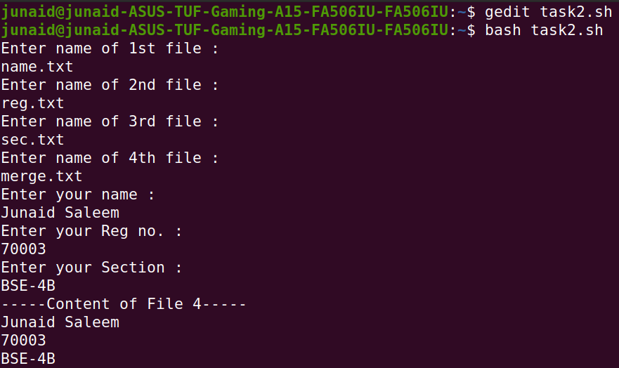

**Task 3: Write a shell script that either performs a file sort, file search or directory listing operation based on the user’s selection of the operation he/she would like to execute.**

**Solution:**

#!/bin/bash

echo "What would you like to perform ?"

echo "1) File Sort"

echo "2) File Search"

echo "3) File Listing"

read opt

if [ $opt = "1" ];

then

echo "Enter File name : "

read filename1

sort $filename1

elif [ $opt = "2" ];

then

echo "Enter File name : "

read filename2

find -iname "$filename"

elif [ $opt = "3" ];

then

echo "Enter Directory :"

read directory

ls $directory

fi

**Output:**

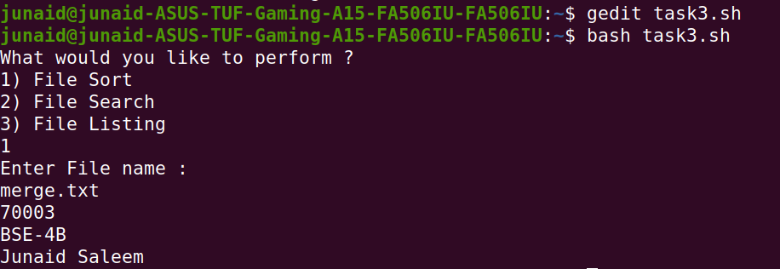

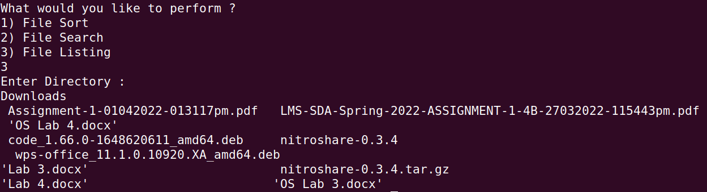

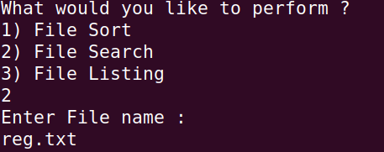

**Task 4: Write a C program that takes values of two matrices of size (𝑚×1) and (1×𝑛) as input from the user. Multiply the above two matrixes and store the resulting (𝑚×𝑛) matrix in a 2D array. Display the contents of the first and second matrices and also the resulting matrix. Achieve alignment in the displayed content as much possible.**

**Solution:**

**Output:**

